# TUGAS

## INSTRUKSI

1. Perhatikan soal-soal di bawah!
2. Tampilkan data berikut menggunakan JOIN & VIEW!
3. Berikan **kode program SQL** dan **screenshot penggunaan kode** tersebut!
4. Disimpan dan disubmit ke kantong tugas dalam format **.docx** atau **.pdf**

**SOAL 21.1 - JOIN TABLE**

|  |  |  |  |  |  |  |
| --- | --- | --- | --- | --- | --- | --- |
| Pesanan | | | Pelanggan | | Kartu | |
| id | tanggal | total | kode | nama | nama kartu | diskon |

SELECT ps.id, ps.tanggal, ps.total, pl.kode, pl.nama, k.nama as nama_kartu, CONCAT((k.diskon * 100), '%') AS diskon

FROM pesanan ps

INNER JOIN pelanggan pl ON ps.pelanggan_id = pl.id

INNER JOIN kartu k ON pl.kartu_id = k.id

ORDER BY id;

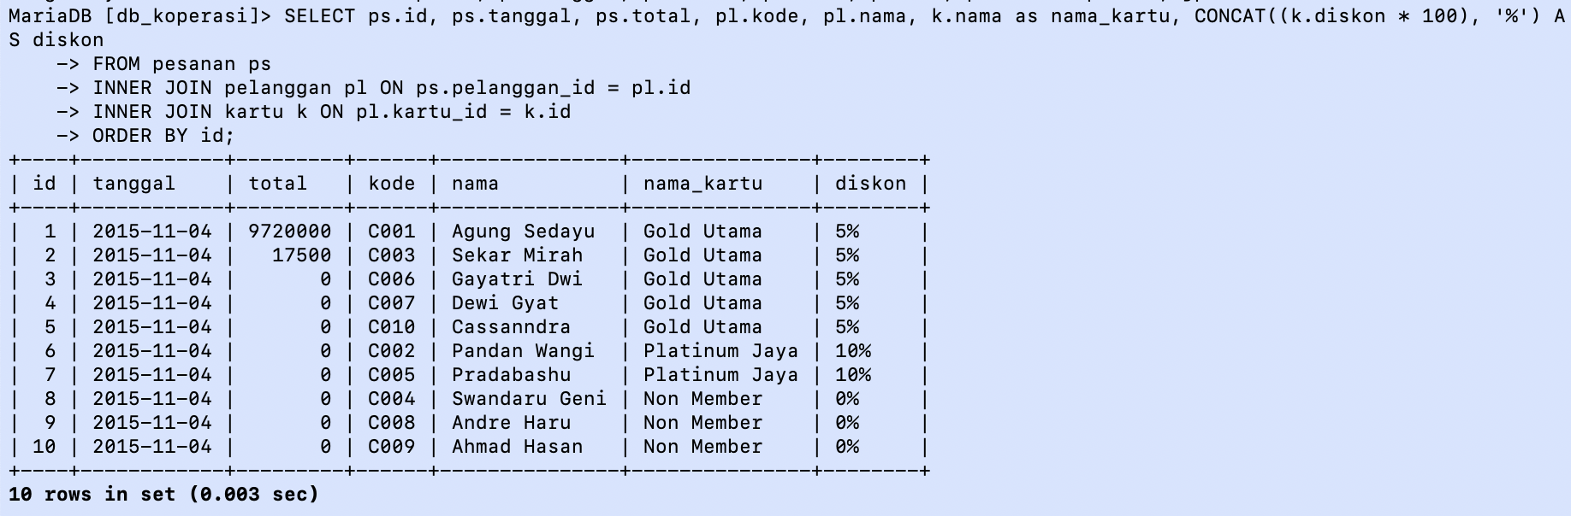



|  |  |  |  |  |  |  |  |
| --- | --- | --- | --- | --- | --- | --- | --- |
| Pembelian | | | | | Produk | Vendor | |
| id | tanggal | nomor | jumlah | harga | nama | nama | kontak |

SELECT pb.id, pb.tanggal, pb.nomor, pb.jumlah, pb.harga, p.nama, v.nama as vendor, v.kontak

FROM pembelian pb

INNER JOIN produk p ON pb.produk_id = p.id

INNER JOIN vendor v ON pb.vendor_id = v.id

ORDER BY id;

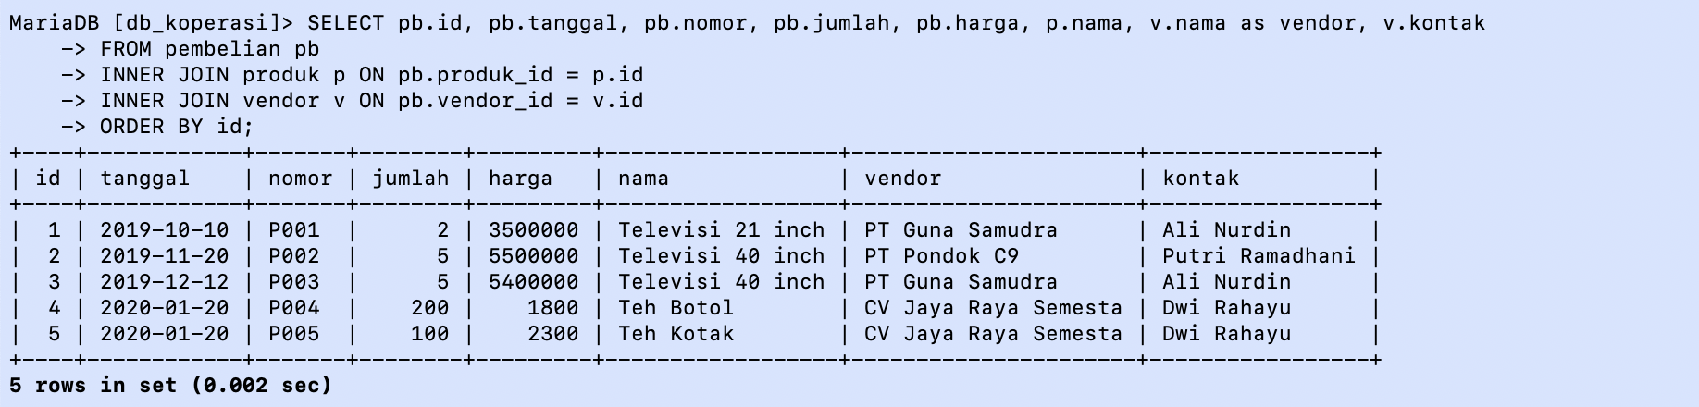



|  |  |  |  |  |  |  |  |  |
| --- | --- | --- | --- | --- | --- | --- | --- | --- |
| Pesanan | | | Pelanggan | Produk | | Jenis produk | Pesanan items | |
| id | tanggal | total | nama | kode | nama | nama | qty | harga_jual |

SELECT ps.id, ps.tanggal, ps.total, pl.nama, p.kode, p.nama as produk, jp.nama as jenis, psi.qty, psi.harga as harga_jual

FROM pesanan ps

INNER JOIN pelanggan pl ON ps.pelanggan_id = pl.id

INNER JOIN pesanan_items psi ON psi.pesanan_id = ps.id

INNER JOIN produk p ON psi.produk_id = p.id

INNER JOIN jenis_produk jp ON jp.id = p.jenis_produk_id

ORDER BY id;

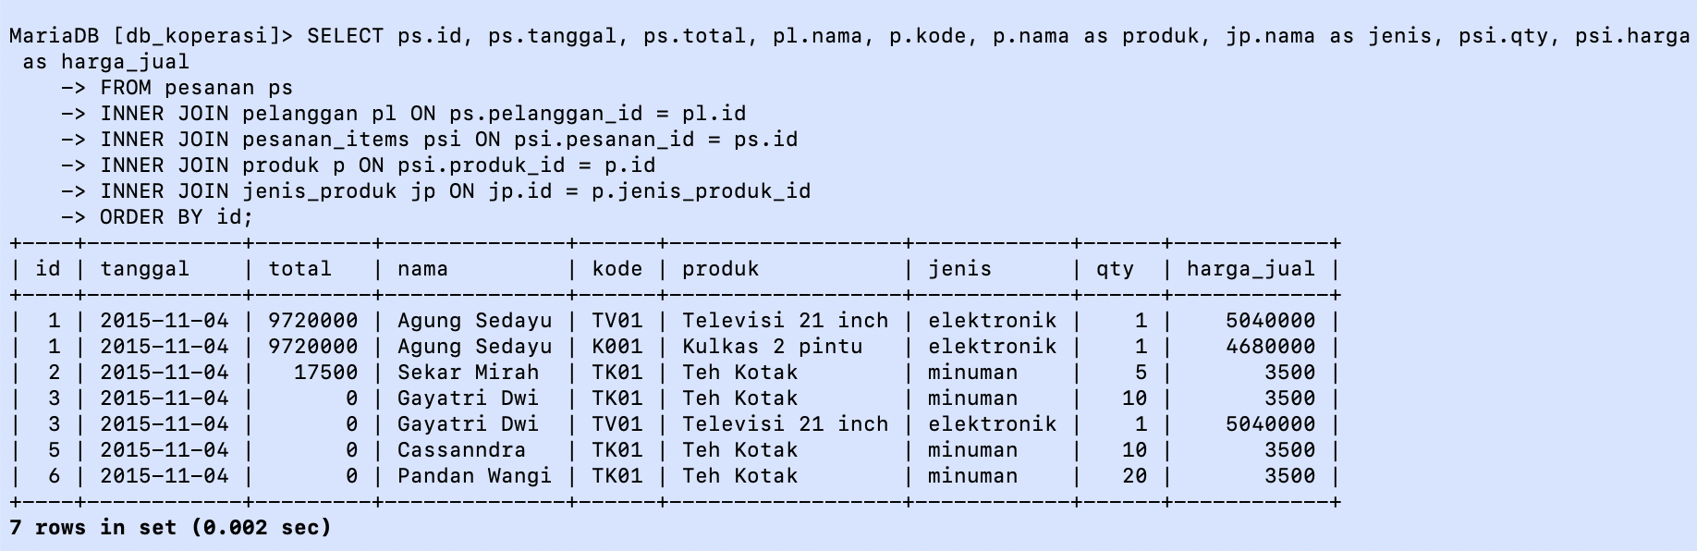

**SOAL 21.2 - VIEW**



|  |  |  |  |  |  |  |
| --- | --- | --- | --- | --- | --- | --- |
| Pesanan | | | Pelanggan | | Kartu | |
| id | tanggal | total | kode | nama | nama kartu | diskon |

CREATE OR REPLACE VIEW vw_pesanan AS

SELECT ps.id, ps.tanggal, ps.total, pl.kode, pl.nama, k.nama as nama_kartu, CONCAT((k.diskon * 100), '%') AS diskon

FROM pesanan ps

INNER JOIN pelanggan pl ON ps.pelanggan_id = pl.id

INNER JOIN kartu k ON pl.kartu_id = k.id

ORDER BY ps.id;

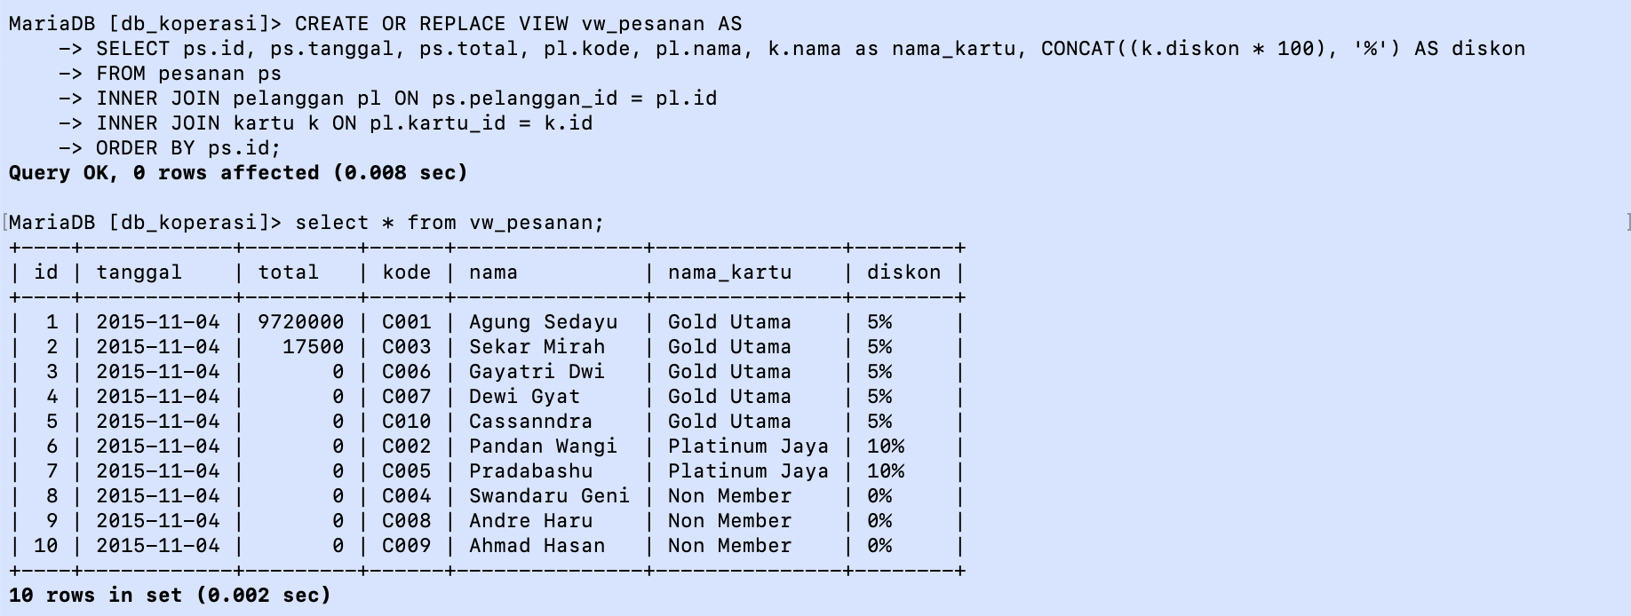



|  |  |  |  |  |  |  |  |
| --- | --- | --- | --- | --- | --- | --- | --- |
| Pembelian | | | | | Produk | Vendor | |
| id | tanggal | nomor | jumlah | harga | nama | nama | kontak |

CREATE OR REPLACE VIEW vw_pembelian AS

SELECT pb.id, pb.tanggal, pb.nomor, pb.jumlah, pb.harga, p.nama as produk, v.nama as vendor, v.kontak

FROM pembelian pb

INNER JOIN produk p ON pb.produk_id = p.id

INNER JOIN vendor v ON pb.vendor_id = v.id

ORDER BY id;

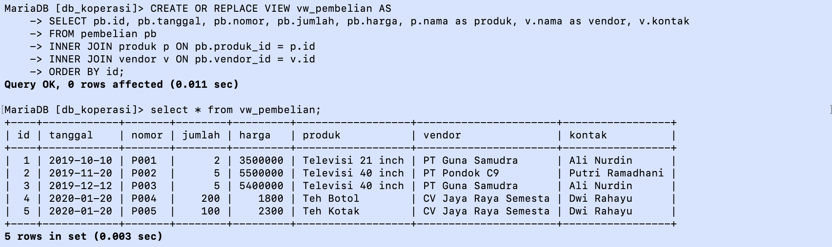



|  |  |  |  |  |  |  |  |  |
| --- | --- | --- | --- | --- | --- | --- | --- | --- |
| Pesanan | | | Pelanggan | Produk | | Jenis produk | Pesanan items | |
| id | tanggal | total | nama | kode | nama | nama | qty | harga_jual |

CREATE OR REPLACE VIEW vw_pesanan AS

SELECT ps.id, ps.tanggal, ps.total, pl.nama, p.kode, p.nama as nama_produk, jp.nama as jenis, psi.qty, psi.harga as harga_jual

FROM pesanan ps

INNER JOIN pelanggan pl ON ps.pelanggan_id = pl.id

INNER JOIN pesanan_items psi ON psi.pesanan_id = ps.id

INNER JOIN produk p ON psi.produk_id = p.id

INNER JOIN jenis_produk jp ON jp.id = p.jenis_produk_id

ORDER BY id;

